Министерство образования Республики Беларусь

Учреждение образования

«Белорусский государственный университет информатики и радиоэлектроники»

Кафедра интеллектуальных информационных технологий

ОТЧЁТ

по лабораторной работе №1

по курсу «Логические основы интеллектуальных систем»

на тему

|  |  |
| --- | --- |
| Проверил:  Ивашенко В.П. | Выполнила:  студент гр. 121701  Волкова О. А. |

Минск, 2014

Для выполнения лабораторной работы, были выполнен набор шагов, отчет о прохождении которых представлен в данном отчете.

1. Разархивировать fs_repo.lib.rar в пустую папку.

2. Запустить консоль командного процессора, перейти в папку с разархивированным fs_repo.lib.rar.

3. Выполнить команду clean для очистки репозитория.

4. Выполнить команду place для трансляции исходных текстов и размещения базы знаний в репозитории.

5. Выполнить команду start cmd.

6. В новом окне командного процессора выполнить команду run -d >log

7. Открыть файл log, убедиться, что тестовые процедуры отработали успешно, без ошибок.

8. Закрыть последнее окно командного процессора.

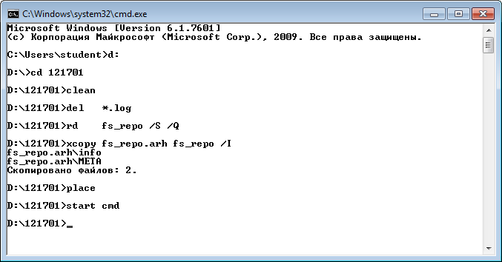

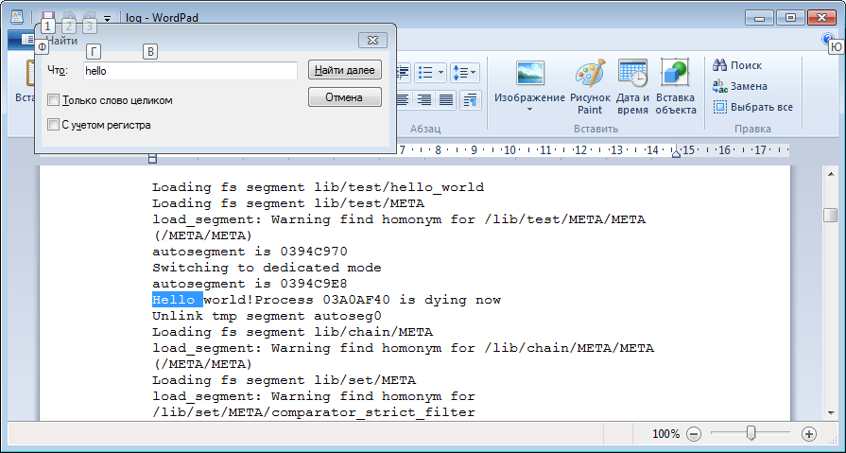

9. В файле /lib/test/main.m4scp вызовы тестовых процедур, кроме hello_world, заключить в макрос DISABLE([ ... ]).

10. Повторить шаги 2-8.

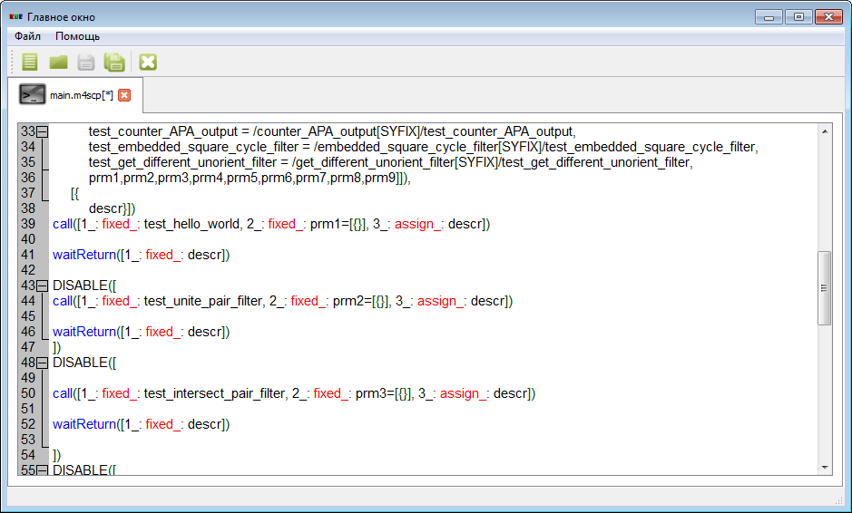

11. Скопировать тестовую процедуру hello_world в новый файл (/lib/test/reverse.m4scp) и соответственно её переименовать.

12. Добавить вызов в main.m4scp.

13. Проверить, повторяя шаги 2-8.

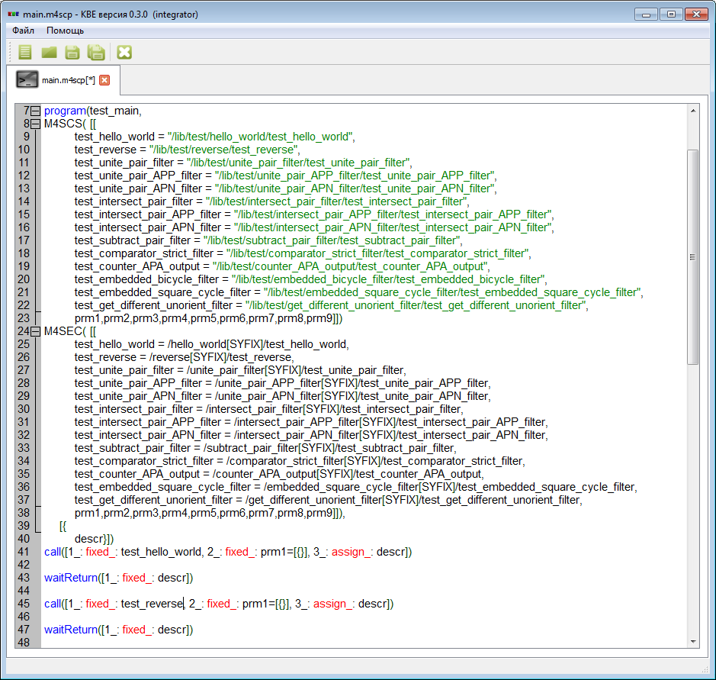

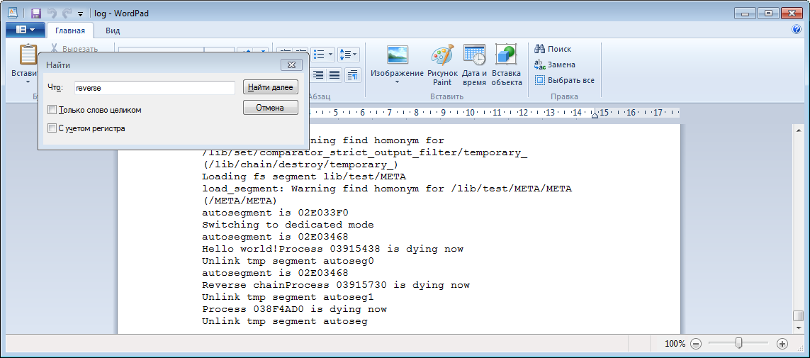

14. Реализовать в тестовой процедуре подготовку тестовых данных с помощью операторов генерации (genEl, genElStr3).

15. Распечатать тестовые данные, используя оператор printEl - аналог оператора print.

16. Проверить, повторяя шаги 2-8.

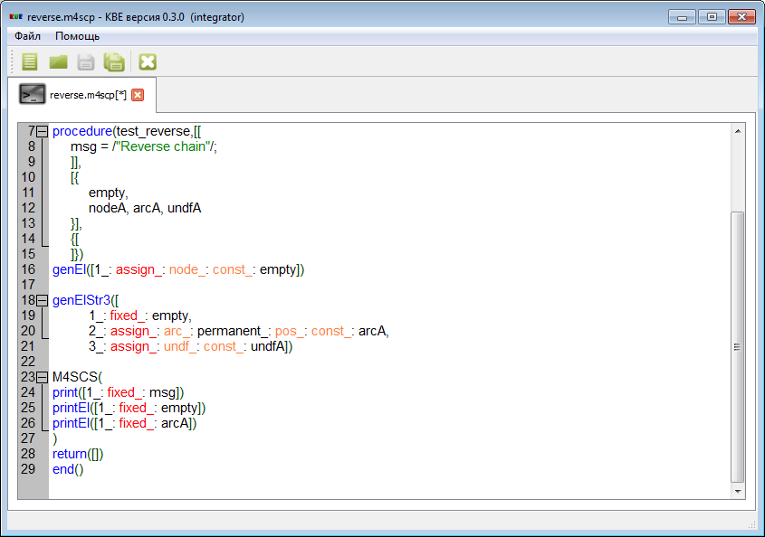

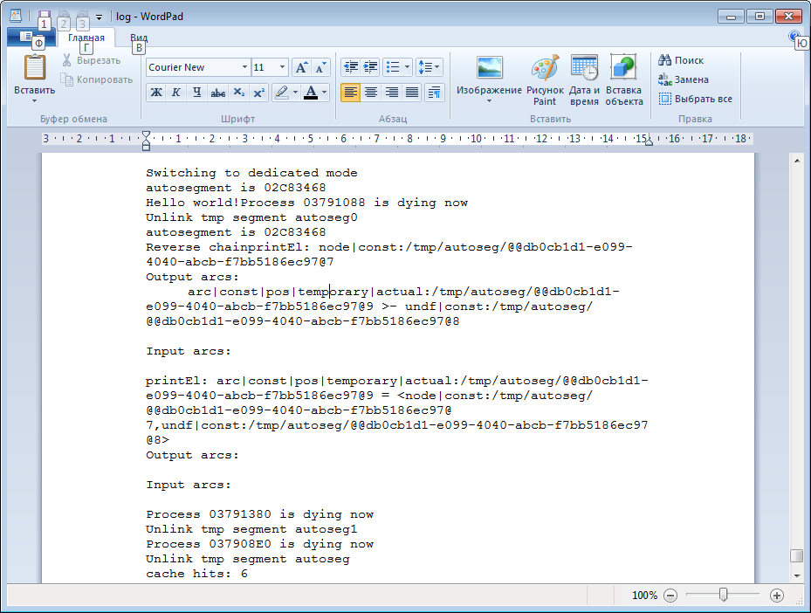

17. Реализовать в тестовой процедуре удаление всех тестовых данных с помощью операторов удаления (eraseEl).

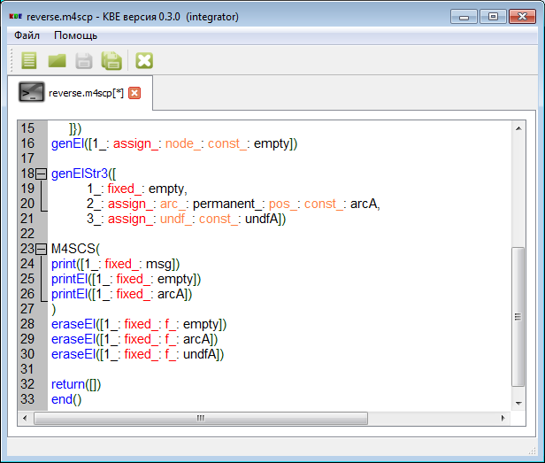

18. Создать пустой узел протоколирования, для передачи в протоколирующие процедуры (logger), добавить оператор его удаления по завершении тестовой процедуры (eraseEl).

19. Реализовать формирование цепочки синглетонов тестовых данных, используя оператор call для вызова процедур push_first_singlet, push_singlet.

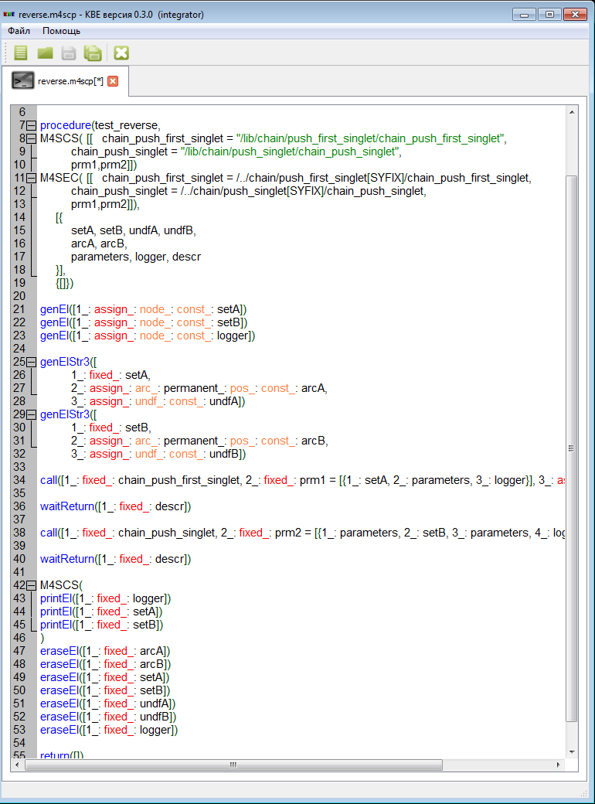

Результат:

Unlink tmp segment autoseg0

Loading fs segment lib/chain/META

load_segment: Warning find homonym for /lib/chain/META/META (/META/META)

autosegment is 0346A900

Loading fs segment lib/log/META

load_segment: Warning find homonym for /lib/log/META/META (/META/META)

autosegment is 0346A9F0

chain_push_first_singlet: entering

autosegment is 0346AA68

autosegment is 0346AAE0

autosegment is 0346AB58

chain_get_next: entering

chain_get_next: leaving

Process 0391CBF0 is dying now

Unlink tmp segment autoseg5

Process 0391BE08 is dying now

Unlink tmp segment autoseg4

Process 0391B138 is dying now

Unlink tmp segment autoseg3

chain_push_first_singlet: leaving

Process 03919F68 is dying now

Unlink tmp segment autoseg2

autosegment is 0346A9F0

chain_push_singlet: entering

autosegment is 0346AA68

autosegment is 0346AAE0

autosegment is 0346AB58

chain_get_next: entering

chain_get_next: leaving

Process 0391D118 is dying now

Unlink tmp segment autoseg9

Process 0391C6C8 is dying now

Unlink tmp segment autoseg8

Process 0391B4F8 is dying now

Unlink tmp segment autoseg7

chain_push_singlet: leaving

Process 0391A238 is dying now

Unlink tmp segment autoseg6

printEl: node|const:/tmp/autoseg/@@5bf1bda6-16d6-4b62-8db1-27969224b8b2@9

Output arcs:

Input arcs:

printEl: node|const:/tmp/autoseg/@@5bf1bda6-16d6-4b62-8db1-27969224b8b2@7

Output arcs:

arc|const|pos|temporary|actual:/tmp/autoseg/@@5bf1bda6-16d6-4b62-8db1-27969224b8b2@b >- undf|const:/tmp/autoseg/@@5bf1bda6-16d6-4b62-8db1-27969224b8b2@a

Input arcs:

arc|const|pos|temporary|actual:/tmp/autoseg/@@5bf1bda6-16d6-4b62-8db1-27969224b8b2@15 -< node|const:/tmp/autoseg/@@5bf1bda6-16d6-4b62-8db1-27969224b8b2@11

printEl: node|const:/tmp/autoseg/@@5bf1bda6-16d6-4b62-8db1-27969224b8b2@8

Output arcs:

arc|const|pos|temporary|actual:/tmp/autoseg/@@5bf1bda6-16d6-4b62-8db1-27969224b8b2@d >- undf|const:/tmp/autoseg/@@5bf1bda6-16d6-4b62-8db1-27969224b8b2@c

Input arcs:

arc|const|pos|temporary|actual:/tmp/autoseg/@@5bf1bda6-16d6-4b62-8db1-27969224b8b2@22 -< node|const:/tmp/autoseg/@@5bf1bda6-16d6-4b62-8db1-27969224b8b2@1e

Process 03918D98 is dying now

Unlink tmp segment autoseg1

Process 03917998 is dying now

Unlink tmp segment autoseg

cache hits: 51

cache misses:101

cache replaces:0

20. Реализовать получение и распечатку тестовых данных из цепочки, используя операторы printEl, ifVarAssign и оператор call для вызова процедуры get_next_singlet.

21. Проверить, повторяя шаги 2-8.

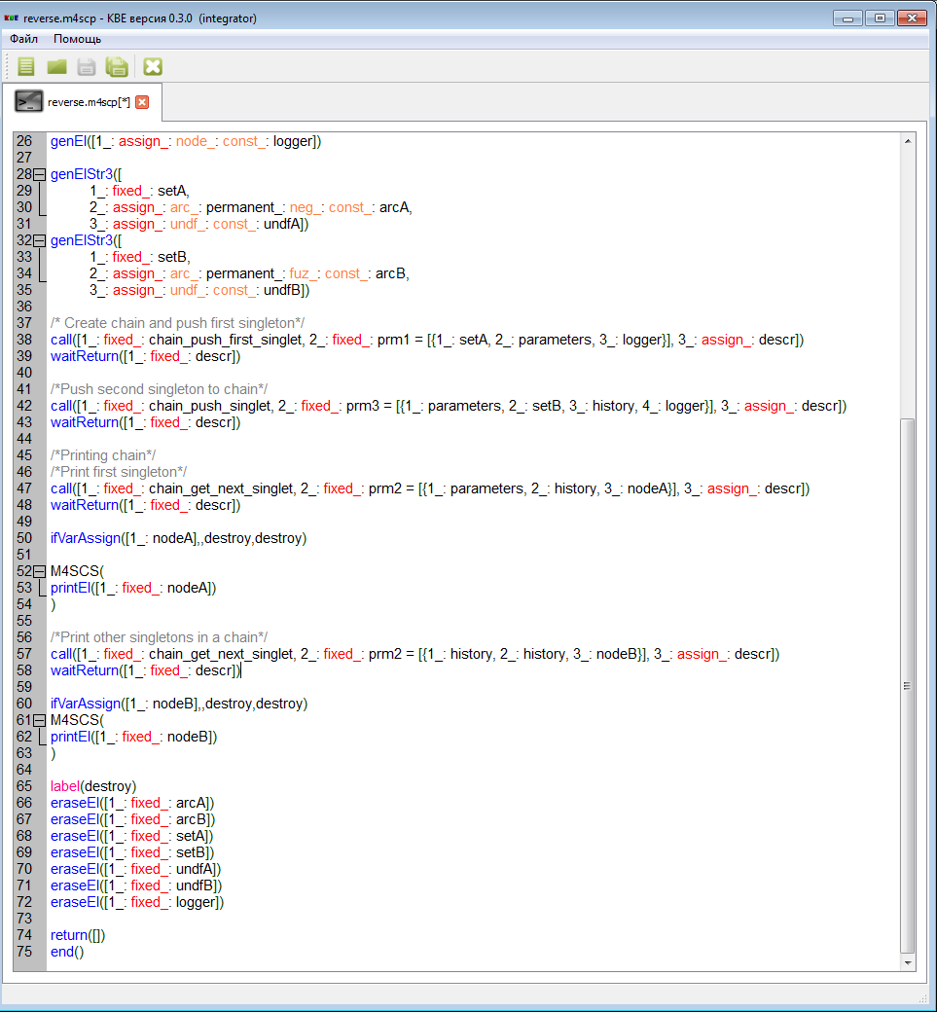

Результат:

autosegment is 034D31F0

chain_get_next_singlet: entering

chain_get_next_singlet: leaving

Process 03980A40 is dying now

Unlink tmp segment autoseg10

printEl: node|const:/tmp/autoseg/@@0322b660-6be3-4c19-b860-8b05746620dd@8

Output arcs:

arc|const|pos|temporary|actual:/tmp/autoseg/@@0322b660-6be3-4c19-b860-8b05746620dd@d >- undf|const:/tmp/autoseg/@@0322b660-6be3-4c19-b860-8b05746620dd@c

Input arcs:

arc|const|pos|temporary|actual:/tmp/autoseg/@@0322b660-6be3-4c19-b860-8b05746620dd@22 -< node|const:/tmp/autoseg/@@0322b660-6be3-4c19-b860-8b05746620dd@1e

autosegment is 034D31F0

chain_get_next_singlet: entering

chain_get_next_singlet: leaving

Process 03980130 is dying now

Unlink tmp segment autoseg11

printEl: node|const:/tmp/autoseg/@@0322b660-6be3-4c19-b860-8b05746620dd@7

Output arcs:

arc|const|pos|temporary|actual:/tmp/autoseg/@@0322b660-6be3-4c19-b860-8b05746620dd@b >- undf|const:/tmp/autoseg/@@0322b660-6be3-4c19-b860-8b05746620dd@a

Input arcs:

arc|const|pos|temporary|actual:/tmp/autoseg/@@0322b660-6be3-4c19-b860-8b05746620dd@15 -< node|const:/tmp/autoseg/@@0322b660-6be3-4c19-b860-8b05746620dd@11

autosegment is 034D31F0

chain_get_next_singlet: entering

chain_get_next_singlet: leaving

Process 03980D38 is dying now

Unlink tmp segment autoseg12

Process 0397EDA8 is dying now

Unlink tmp segment autoseg1

Process 0397D9F8 is dying now

Unlink tmp segment autoseg

cache hits: 82

cache misses:135

cache replaces:0

22. Реализовать удаление данных из цепочки и самой цепочки, используя оператор ifVarAssign и оператор call для вызова процедур pop_destroy_singlet и destroy.

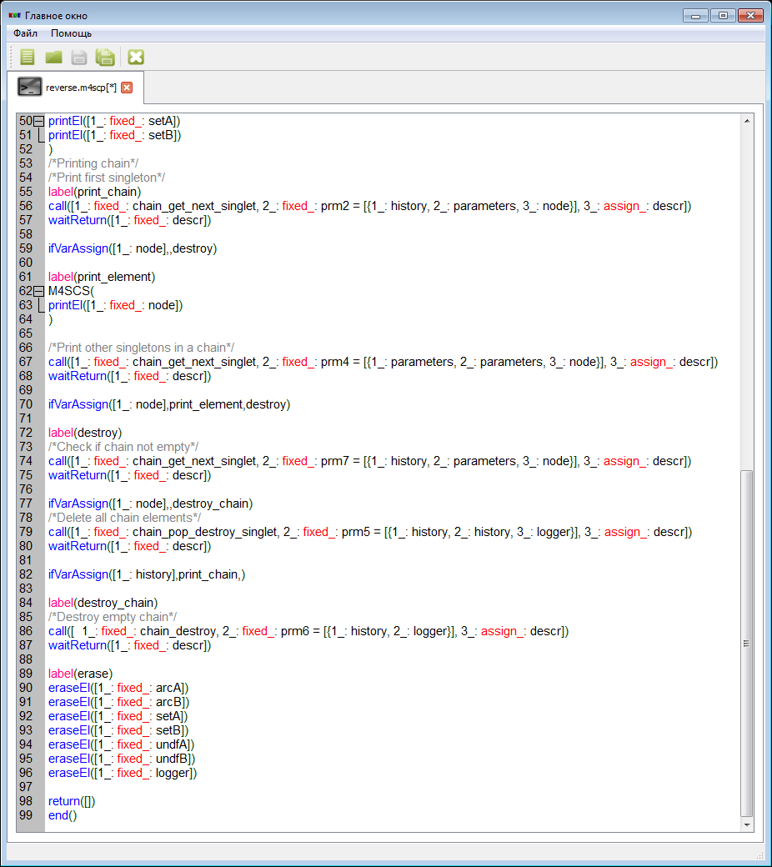

Результат:

Unlink tmp segment autoseg7

chain_push_singlet: leaving

Process 03BBF808 is dying now

Unlink tmp segment autoseg6

printEl: node|const:/tmp/autoseg/@@c25b81c2-bb0a-43ae-8f6f-8858a903d9d8@7

Output arcs:

arc|const|pos|temporary|actual:/tmp/autoseg/@@c25b81c2-bb0a-43ae-8f6f-8858a903d9d8@b >- undf|const:/tmp/autoseg/@@c25b81c2-bb0a-43ae-8f6f-8858a903d9d8@a

Input arcs:

arc|const|pos|temporary|actual:/tmp/autoseg/@@c25b81c2-bb0a-43ae-8f6f-8858a903d9d8@15 -< node|const:/tmp/autoseg/@@c25b81c2-bb0a-43ae-8f6f-8858a903d9d8@11

printEl: node|const:/tmp/autoseg/@@c25b81c2-bb0a-43ae-8f6f-8858a903d9d8@8

Output arcs:

arc|const|pos|temporary|actual:/tmp/autoseg/@@c25b81c2-bb0a-43ae-8f6f-8858a903d9d8@d >- undf|const:/tmp/autoseg/@@c25b81c2-bb0a-43ae-8f6f-8858a903d9d8@c

Input arcs:

arc|const|pos|temporary|actual:/tmp/autoseg/@@c25b81c2-bb0a-43ae-8f6f-8858a903d9d8@22 -< node|const:/tmp/autoseg/@@c25b81c2-bb0a-43ae-8f6f-8858a903d9d8@1e

autosegment is 030E35D0

chain_get_next_singlet: entering

chain_get_next_singlet: leaving

Process 03BBFF88 is dying now

Unlink tmp segment autoseg10

printEl: node|const:/tmp/autoseg/@@c25b81c2-bb0a-43ae-8f6f-8858a903d9d8@8

Output arcs:

arc|const|pos|temporary|actual:/tmp/autoseg/@@c25b81c2-bb0a-43ae-8f6f-8858a903d9d8@d >- undf|const:/tmp/autoseg/@@c25b81c2-bb0a-43ae-8f6f-8858a903d9d8@c

Input arcs:

arc|const|pos|temporary|actual:/tmp/autoseg/@@c25b81c2-bb0a-43ae-8f6f-8858a903d9d8@22 -< node|const:/tmp/autoseg/@@c25b81c2-bb0a-43ae-8f6f-8858a903d9d8@1e

autosegment is 030E35D0

chain_get_next_singlet: entering

chain_get_next_singlet: leaving

Process 03BBF678 is dying now

Unlink tmp segment autoseg11

printEl: node|const:/tmp/autoseg/@@c25b81c2-bb0a-43ae-8f6f-8858a903d9d8@7

Output arcs:

arc|const|pos|temporary|actual:/tmp/autoseg/@@c25b81c2-bb0a-43ae-8f6f-8858a903d9d8@b >- undf|const:/tmp/autoseg/@@c25b81c2-bb0a-43ae-8f6f-8858a903d9d8@a

Input arcs:

arc|const|pos|temporary|actual:/tmp/autoseg/@@c25b81c2-bb0a-43ae-8f6f-8858a903d9d8@15 -< node|const:/tmp/autoseg/@@c25b81c2-bb0a-43ae-8f6f-8858a903d9d8@11

autosegment is 030E35D0

chain_get_next_singlet: entering

chain_get_next_singlet: leaving

Process 03BC0280 is dying now

Unlink tmp segment autoseg12

autosegment is 030E35D0

chain_get_next_singlet: entering

chain_get_next_singlet: leaving

Process 03BC0820 is dying now

Unlink tmp segment autoseg13

autosegment is 030E35D0

chain_pop_destroy_singlet: entering

autosegment is 030E3648

chain_get_next: entering

chain_get_next: leaving

Process 03BC15B8 is dying now

Unlink tmp segment autoseg15

autosegment is 030E3648

autosegment is 030E36C0

autosegment is 030E3738

chain_get_next: entering

chain_get_next: leaving

Process 03BC2F80 is dying now

Unlink tmp segment autoseg18

Process 03BC2288 is dying now

Unlink tmp segment autoseg17

Process 03BC32F0 is dying now

Unlink tmp segment autoseg16

chain_pop_destroy_singlet: leaving

Process 03BC0C30 is dying now

Unlink tmp segment autoseg14

autosegment is 030E35D0

chain_get_next_singlet: entering

chain_get_next_singlet: leaving

Process 03BC21C0 is dying now

Unlink tmp segment autoseg19

printEl: node|const:/tmp/autoseg/@@c25b81c2-bb0a-43ae-8f6f-8858a903d9d8@7

Output arcs:

arc|const|pos|temporary|actual:/tmp/autoseg/@@c25b81c2-bb0a-43ae-8f6f-8858a903d9d8@b >- undf|const:/tmp/autoseg/@@c25b81c2-bb0a-43ae-8f6f-8858a903d9d8@a

Input arcs:

arc|const|pos|temporary|actual:/tmp/autoseg/@@c25b81c2-bb0a-43ae-8f6f-8858a903d9d8@15 -< node|const:/tmp/autoseg/@@c25b81c2-bb0a-43ae-8f6f-8858a903d9d8@11

autosegment is 030E35D0

chain_get_next_singlet: entering

chain_get_next_singlet: leaving

Process 03BBF9E8 is dying now

Unlink tmp segment autoseg20

autosegment is 030E35D0

chain_get_next_singlet: entering

chain_get_next_singlet: leaving

Process 03BBF998 is dying now

Unlink tmp segment autoseg21

autosegment is 030E35D0

chain_pop_destroy_singlet: entering

autosegment is 030E3648

chain_get_next: entering

chain_get_next: leaving

Process 03BC01B8 is dying now

Unlink tmp segment autoseg23

autosegment is 030E3648

autosegment is 030E36C0

autosegment is 030E3738

chain_get_next: entering

chain_get_next: leaving

Process 03BC3610 is dying now

Unlink tmp segment autoseg26

Process 03BC3188 is dying now

Unlink tmp segment autoseg25

Process 03BC19C8 is dying now

Unlink tmp segment autoseg24

chain_pop_destroy_singlet: leaving

Process 03BC2E68 is dying now

Unlink tmp segment autoseg22

autosegment is 030E35D0

chain_get_next_singlet: entering

chain_get_next_singlet: leaving

Process 03BC2940 is dying now

Unlink tmp segment autoseg27

autosegment is 030E35D0

chain_get_next_singlet: entering

chain_get_next_singlet: leaving

Process 03BC1158 is dying now

Unlink tmp segment autoseg28

autosegment is 030E35D0

chain_destroy: entering

autosegment is 030E3648

autosegment is 030E36C0

autosegment is 030E3738

chain_get_next: entering

chain_get_next: leaving

Process 03BC37F0 is dying now

Unlink tmp segment autoseg32

Process 03BC3368 is dying now

Unlink tmp segment autoseg31

Process 03BC3098 is dying now

Unlink tmp segment autoseg30

autosegment is 030E3648

chain_get_next: entering

chain_get_next: leaving

Process 03BC1540 is dying now

Unlink tmp segment autoseg33

chain_destroy: leaving

Process 03BC0D48 is dying now

Unlink tmp segment autoseg29

Process 03BBE2F0 is dying now

Unlink tmp segment autoseg1

Process 03BBCEC8 is dying now

Unlink tmp segment autoseg

cache hits: 210

cache misses:332

cache replaces:0

23. Реализовать подпрограмму - процедуру построения перевёрнутой цепочки (/lib/chain/reverse/chain_reverse)

24. Добавить вызов реализованной процедуры (/lib/chain/reverse/chain_reverse) в тестовую процедуру.

25. Отладить и протестировать /lib/chain/reverse/chain_reverse.

Текст программы /lib/chain/reverse/chain_reverse:

{[

1_: in_: out_: state,

2_: in_: out_: true,

3_: in_: out_: history,

4_: in_: parameters,

5_: in_: logging

]})

DBG(M4SCS(print([1_: fixed_: enter_message])))

genEl([1_: assign_: node_: const_: empty])

call([1_: fixed_: chain_get_next_singlet, 2_: fixed_: prm1 = [{1_: history, 2_: link, 3_: old_chain}], 3_: assign_: descr])

waitReturn([1_: fixed_: descr])

ifVarAssign([1_: old_chain],,destroy_final)

call([1_: fixed_: chain_get_next_singlet, 2_: fixed_: prm2 = [{1_: old_chain, 2_: link, 3_: node}], 3_: assign_: descr])

waitReturn([1_: fixed_: descr])

ifVarAssign([1_: node],,destroy)

call([1_: fixed_: chain_pop_destroy_singlet, 2_: fixed_: prm3 = [{1_: old_chain, 2_: old_chain, 3_: logging}], 3_: assign_: descr])

waitReturn([1_: fixed_: descr])

call([1_: fixed_: chain_push_first_singlet, 2_: fixed_: prm4 = [{1_: node, 2_: new_chain, 3_: logging}], 3_: assign_: descr])

waitReturn([1_: fixed_: descr])

label(next)

call([1_: fixed_: chain_get_next_singlet, 2_: fixed_: prm5 = [{1_: old_chain, 2_: link, 3_: node}], 3_: assign_: descr])

waitReturn([1_: fixed_: descr])

ifVarAssign([1_: node],,push)

call([1_: fixed_: chain_pop_destroy_singlet, 2_: fixed_: prm6 = [{1_: old_chain, 2_: old_chain, 3_: logging}], 3_: assign_: descr])

waitReturn([1_: fixed_: descr])

call([1_: fixed_: chain_push_singlet, 2_: fixed_: prm7 = [{1_: new_chain, 2_: node, 3_: new_chain, 4_: logging}], 3_: assign_: descr])

waitReturn([1_: fixed_: descr],next,next)

label(push)

call([1_: fixed_: chain_push_singlet, 2_: fixed_: prm8 = [{1_: history, 2_: new_chain, 3_: history, 4_: logging}], 3_: assign_: descr])

waitReturn([1_: fixed_: descr])

label(destroy)

call([ 1_: fixed_: chain_destroy, 2_: fixed_: prm9 = [{1_: old_chain, 2_: logging}], 3_: assign_: descr])

waitReturn([1_: fixed_: descr])

label(destroy_final)

eraseEl([1_: fixed_: f_: empty])

DBG(M4SCS(print([1_: fixed_: leave_message])))

return()

end()

Алгоритм:

На вход подпрограммы приходит метацепочка history, в которой первым элементом является

Тестирование программы:

[{

setA, setB,

undfA, undfB,

arcA, arcB,

chain_top_link, meta_chain_link, link,

logger, descr, node, empty

}],

{[]})

genEl([1_: assign_: node_: const_: setA])

genEl([1_: assign_: node_: const_: setB])

genEl([1_: assign_: node_: const_: logger])

genEl([1_: assign_: node_: const_: empty])

genElStr3([

1_: fixed_: setA,

2_: assign_: arc_: permanent_: pos_: const_: arcA,

3_: assign_: undf_: const_: undfA])

genElStr3([

1_: fixed_: setB,

2_: assign_: arc_: permanent_: pos_: const_: arcB,

3_: assign_: undf_: const_: undfB])

/* Create chain and push first singleton*/

call([1_: fixed_: chain_push_first_singlet, 2_: fixed_: prm1 = [{1_: setA, 2_: chain_top_link, 3_: logger}], 3_: assign_: descr])

waitReturn([1_: fixed_: descr])

/*Push second singleton to chain*/

call([1_: fixed_: chain_push_singlet, 2_: fixed_: prm3 = [{1_: chain_top_link, 2_: setB, 3_: chain_top_link, 4_: logger}], 3_: assign_: descr])

waitReturn([1_: fixed_: descr])

M4SCS(

printEl([1_: fixed_: setA])

printEl([1_: fixed_: setB])

)

/*Printing chain*/

/*Print first singleton*/

label(print_chain)

call([1_: fixed_: chain_get_next_singlet, 2_: fixed_: prm2 = [{1_: chain_top_link, 2_: link, 3_: node}], 3_: assign_: descr])

waitReturn([1_: fixed_: descr])

ifVarAssign([1_: node],,reverse)

label(print_element)

M4SCS(

printEl([1_: fixed_: node])

)

/*Print other singletons in a chain*/

call([1_: fixed_: chain_get_next_singlet, 2_: fixed_: prm4 = [{1_: link, 2_: link, 3_: node}], 3_: assign_: descr])

waitReturn([1_: fixed_: descr])

ifVarAssign([1_: node],print_element,reverse)

label(reverse)

/*Reverse chain*/

call([1_: fixed_: chain_push_first_singlet, 2_: fixed_: prmD = [{1_: chain_top_link, 2_: meta_chain_link, 3_: logger}], 3_: assign_: descr])

waitReturn([1_: fixed_: descr])

call([1_: fixed_: chain_reverse, 2_: fixed_: prm9 = [{1_: empty, 2_: empty, 3_: meta_chain_link, 4_: empty, 5_: logger}], 3_: assign_: descr])

waitReturn([1_: fixed_: descr])

call([1_: fixed_: chain_get_next_singlet, 2_: fixed_: prmC = [{1_: meta_chain_link, 2_: link, 3_: chain_top_link}], 3_: assign_: descr])

waitReturn([1_: fixed_: descr])

label(print_chain1)

call([1_: fixed_: chain_get_next_singlet, 2_: fixed_: prmA = [{1_: chain_top_link, 2_: link, 3_: node}], 3_: assign_: descr])

waitReturn([1_: fixed_: descr])

ifVarAssign([1_: node],,destroy)

label(print_element1)

M4SCS(

printEl([1_: fixed_: node])

)

/*Print other singletons in a chain*/

call([1_: fixed_: chain_get_next_singlet, 2_: fixed_: prmB = [{1_: link, 2_: link, 3_: node}], 3_: assign_: descr])

waitReturn([1_: fixed_: descr])

ifVarAssign([1_: node],print_element1,destroy)

label(destroy)

ifVarAssign([1_: chain_top_link],,erase)

/*Check if chain not empty*/

call([1_: fixed_: chain_get_next_singlet, 2_: fixed_: prm7 = [{1_: chain_top_link, 2_: link, 3_: node}], 3_: assign_: descr])

waitReturn([1_: fixed_: descr])

ifVarAssign([1_: node],,destroy_chain)

/*Delete all chain elements*/

call([1_: fixed_: chain_pop_destroy_singlet, 2_: fixed_: prm5 = [{1_: chain_top_link, 2_: chain_top_link, 3_: logger}], 3_: assign_: descr])

waitReturn([1_: fixed_: descr])

ifVarAssign([1_: chain_top_link],destroy,)

label(destroy_chain)

/*Destroy empty chain*/

call([ 1_: fixed_: chain_destroy, 2_: fixed_: prm6 = [{1_: chain_top_link, 2_: logger}], 3_: assign_: descr])

waitReturn([1_: fixed_: descr])

label(erase)

eraseEl([1_: fixed_: arcA])

eraseEl([1_: fixed_: arcB])

eraseEl([1_: fixed_: setA])

eraseEl([1_: fixed_: setB])

eraseEl([1_: fixed_: undfA])

eraseEl([1_: fixed_: undfB])

eraseEl([1_: fixed_: logger])

eraseEl([1_: fixed_: empty])

return([])

end()

лог:

Hello world!Process 03C188F0 is dying now

Unlink tmp segment autoseg0

Loading fs segment lib/chain/META

load_segment: Warning find homonym for /lib/chain/META/META (/META/META)

load_segment: Warning find homonym for /lib/chain/META/reverse (/lib/test/META/reverse)

autosegment is 03740980

Loading fs segment lib/log/META

load_segment: Warning find homonym for /lib/log/META/META (/META/META)

autosegment is 03740A70

chain_push_first_singlet: entering

autosegment is 03740AE8

autosegment is 03740B60

autosegment is 03740BD8

chain_get_next: entering

chain_get_next: leaving

Process 03C91688 is dying now

Unlink tmp segment autoseg5

Process 03C908A0 is dying now

Unlink tmp segment autoseg4

Process 03C8FBD0 is dying now

Unlink tmp segment autoseg3

chain_push_first_singlet: leaving

Process 03C1A998 is dying now

Unlink tmp segment autoseg2

autosegment is 03740A70

chain_push_singlet: entering

autosegment is 03740AE8

autosegment is 03740B60

autosegment is 03740BD8

chain_get_next: entering

chain_get_next: leaving

Process 03C91C50 is dying now

Unlink tmp segment autoseg9

Process 03C91138 is dying now

Unlink tmp segment autoseg8

Process 03C906C0 is dying now

Unlink tmp segment autoseg7

chain_push_singlet: leaving

Process 03C1AB78 is dying now

Unlink tmp segment autoseg6

printEl: node|const:/tmp/autoseg/@@74c22f2b-20f9-474a-b015-cafe579c9aac@7

Output arcs:

arc|const|pos|temporary|actual:/tmp/autoseg/@@74c22f2b-20f9-474a-b015-cafe579c9aac@c >- undf|const:/tmp/autoseg/@@74c22f2b-20f9-474a-b015-cafe579c9aac@b

Input arcs:

arc|const|pos|temporary|actual:/tmp/autoseg/@@74c22f2b-20f9-474a-b015-cafe579c9aac@16 -< node|const:/tmp/autoseg/@@74c22f2b-20f9-474a-b015-cafe579c9aac@12

printEl: node|const:/tmp/autoseg/@@74c22f2b-20f9-474a-b015-cafe579c9aac@8

Output arcs:

arc|const|pos|temporary|actual:/tmp/autoseg/@@74c22f2b-20f9-474a-b015-cafe579c9aac@e >- undf|const:/tmp/autoseg/@@74c22f2b-20f9-474a-b015-cafe579c9aac@d

Input arcs:

arc|const|pos|temporary|actual:/tmp/autoseg/@@74c22f2b-20f9-474a-b015-cafe579c9aac@23 -< node|const:/tmp/autoseg/@@74c22f2b-20f9-474a-b015-cafe579c9aac@1f

autosegment is 03740A70

chain_get_next_singlet: entering

chain_get_next_singlet: leaving

Process 03C8F1F8 is dying now

Unlink tmp segment autoseg10

printEl: node|const:/tmp/autoseg/@@74c22f2b-20f9-474a-b015-cafe579c9aac@8

Output arcs:

arc|const|pos|temporary|actual:/tmp/autoseg/@@74c22f2b-20f9-474a-b015-cafe579c9aac@e >- undf|const:/tmp/autoseg/@@74c22f2b-20f9-474a-b015-cafe579c9aac@d

Input arcs:

arc|const|pos|temporary|actual:/tmp/autoseg/@@74c22f2b-20f9-474a-b015-cafe579c9aac@23 -< node|const:/tmp/autoseg/@@74c22f2b-20f9-474a-b015-cafe579c9aac@1f

autosegment is 03740A70

chain_get_next_singlet: entering

chain_get_next_singlet: leaving

Process 03C8ECD0 is dying now

Unlink tmp segment autoseg11

printEl: node|const:/tmp/autoseg/@@74c22f2b-20f9-474a-b015-cafe579c9aac@7

Output arcs:

arc|const|pos|temporary|actual:/tmp/autoseg/@@74c22f2b-20f9-474a-b015-cafe579c9aac@c >- undf|const:/tmp/autoseg/@@74c22f2b-20f9-474a-b015-cafe579c9aac@b

Input arcs:

arc|const|pos|temporary|actual:/tmp/autoseg/@@74c22f2b-20f9-474a-b015-cafe579c9aac@16 -< node|const:/tmp/autoseg/@@74c22f2b-20f9-474a-b015-cafe579c9aac@12

autosegment is 03740A70

chain_get_next_singlet: entering

chain_get_next_singlet: leaving

Process 03C8F748 is dying now

Unlink tmp segment autoseg12

autosegment is 03740A70

chain_push_first_singlet: entering

autosegment is 03740AE8

autosegment is 03740B60

autosegment is 03740BD8

chain_get_next: entering

chain_get_next: leaving

Process 03C92380 is dying now

Unlink tmp segment autoseg16

Process 03C91F48 is dying now

Unlink tmp segment autoseg15

Process 03C8FC70 is dying now

Unlink tmp segment autoseg14

chain_push_first_singlet: leaving

Process 03C8FF40 is dying now

Unlink tmp segment autoseg13

autosegment is 03740A70

chain_reverse: entering

autosegment is 03740AE8

chain_get_next_singlet: entering

chain_get_next_singlet: leaving

Process 03C91F98 is dying now

Unlink tmp segment autoseg18

autosegment is 03740AE8

chain_get_next_singlet: entering

chain_get_next_singlet: leaving

Process 03C90DA0 is dying now

Unlink tmp segment autoseg19

autosegment is 03740AE8

chain_pop_destroy_singlet: entering

autosegment is 03740B60

chain_get_next: entering

chain_get_next: leaving

Process 03C917A0 is dying now

Unlink tmp segment autoseg21

autosegment is 03740B60

autosegment is 03740BD8

autosegment is 03740C50

chain_get_next: entering

chain_get_next: leaving

Process 03C94108 is dying now

Unlink tmp segment autoseg24

Process 03C93528 is dying now

Unlink tmp segment autoseg23

Process 03C92C68 is dying now

Unlink tmp segment autoseg22

chain_pop_destroy_singlet: leaving

Process 03C90FD0 is dying now

Unlink tmp segment autoseg20

autosegment is 03740AE8

chain_push_first_singlet: entering

autosegment is 03740B60

autosegment is 03740BD8

autosegment is 03740C50

chain_get_next: entering

chain_get_next: leaving

Process 03C94798 is dying now

Unlink tmp segment autoseg28

Process 03C938E8 is dying now

Unlink tmp segment autoseg27

Process 03C92AD8 is dying now

Unlink tmp segment autoseg26

chain_push_first_singlet: leaving

Process 03C91F48 is dying now

Unlink tmp segment autoseg25

autosegment is 03740AE8

chain_get_next_singlet: entering

chain_get_next_singlet: leaving

Process 03C918B8 is dying now

Unlink tmp segment autoseg29

autosegment is 03740AE8

chain_pop_destroy_singlet: entering

autosegment is 03740B60

chain_get_next: entering

chain_get_next: leaving

Process 03C90F58 is dying now

Unlink tmp segment autoseg31

autosegment is 03740B60

autosegment is 03740BD8

autosegment is 03740C50

chain_get_next: entering

chain_get_next: leaving

Process 03C94680 is dying now

Unlink tmp segment autoseg34

Process 03C93D48 is dying now

Unlink tmp segment autoseg33

Process 03C93FF0 is dying now

Unlink tmp segment autoseg32

chain_pop_destroy_singlet: leaving

Process 03C925B0 is dying now

Unlink tmp segment autoseg30

autosegment is 03740AE8

chain_push_singlet: entering

autosegment is 03740B60

autosegment is 03740BD8

autosegment is 03740C50

chain_get_next: entering

chain_get_next: leaving

Process 03C95170 is dying now

Unlink tmp segment autoseg38

Process 03C92D30 is dying now

Unlink tmp segment autoseg37

Process 03C93730 is dying now

Unlink tmp segment autoseg36

chain_push_singlet: leaving

Process 03C91778 is dying now

Unlink tmp segment autoseg35

autosegment is 03740AE8

chain_get_next_singlet: entering

chain_get_next_singlet: leaving

Process 03C90DF0 is dying now

Unlink tmp segment autoseg39

autosegment is 03740AE8

chain_push_singlet: entering

autosegment is 03740B60

autosegment is 03740BD8

autosegment is 03740C50

chain_get_next: entering

chain_get_next: leaving

Process 03C945E0 is dying now

Unlink tmp segment autoseg43

Process 03C935A0 is dying now

Unlink tmp segment autoseg42

Process 03C932F8 is dying now

Unlink tmp segment autoseg41

chain_push_singlet: leaving

Process 03C92B50 is dying now

Unlink tmp segment autoseg40

autosegment is 03740AE8

chain_destroy: entering

autosegment is 03740B60

autosegment is 03740BD8

autosegment is 03740C50

chain_get_next: entering

chain_get_next: leaving

Process 03C95238 is dying now

Unlink tmp segment autoseg47

Process 03C94248 is dying now

Unlink tmp segment autoseg46

Process 03C94068 is dying now

Unlink tmp segment autoseg45

autosegment is 03740B60

chain_get_next: entering

chain_get_next: leaving

Process 03C93690 is dying now

Unlink tmp segment autoseg48

chain_destroy: leaving

Process 03C94568 is dying now

Unlink tmp segment autoseg44

chain_reverse: leaving

Process 03C8F4F0 is dying now

Unlink tmp segment autoseg17

autosegment is 03740A70

chain_get_next_singlet: entering

chain_get_next_singlet: leaving

Process 03C90B98 is dying now

Unlink tmp segment autoseg49

autosegment is 03740A70

chain_get_next_singlet: entering

chain_get_next_singlet: leaving

Process 03C91138 is dying now

Unlink tmp segment autoseg50

printEl: node|const:/tmp/autoseg/@@74c22f2b-20f9-474a-b015-cafe579c9aac@7

Output arcs:

arc|const|pos|temporary|actual:/tmp/autoseg/@@74c22f2b-20f9-474a-b015-cafe579c9aac@c >- undf|const:/tmp/autoseg/@@74c22f2b-20f9-474a-b015-cafe579c9aac@b

Input arcs:

arc|const|pos|temporary|actual:/tmp/autoseg/@@74c22f2b-20f9-474a-b015-cafe579c9aac@6f -< node|const:/tmp/autoseg/@@74c22f2b-20f9-474a-b015-cafe579c9aac@6b

autosegment is 03740A70

chain_get_next_singlet: entering

chain_get_next_singlet: leaving

Process 03C900A8 is dying now

Unlink tmp segment autoseg51

printEl: node|const:/tmp/autoseg/@@74c22f2b-20f9-474a-b015-cafe579c9aac@8

Output arcs:

arc|const|pos|temporary|actual:/tmp/autoseg/@@74c22f2b-20f9-474a-b015-cafe579c9aac@e >- undf|const:/tmp/autoseg/@@74c22f2b-20f9-474a-b015-cafe579c9aac@d

Input arcs:

arc|const|pos|temporary|actual:/tmp/autoseg/@@74c22f2b-20f9-474a-b015-cafe579c9aac@56 -< node|const:/tmp/autoseg/@@74c22f2b-20f9-474a-b015-cafe579c9aac@52

autosegment is 03740A70

chain_get_next_singlet: entering

chain_get_next_singlet: leaving

Process 03C91818 is dying now

Unlink tmp segment autoseg52

autosegment is 03740A70

chain_get_next_singlet: entering

chain_get_next_singlet: leaving

Process 03C91AE8 is dying now

Unlink tmp segment autoseg53

autosegment is 03740A70

chain_pop_destroy_singlet: entering

autosegment is 03740AE8

chain_get_next: entering

chain_get_next: leaving

Process 03C926A0 is dying now

Unlink tmp segment autoseg55

autosegment is 03740AE8

autosegment is 03740B60

autosegment is 03740BD8

chain_get_next: entering

chain_get_next: leaving

Process 03C95030 is dying now

Unlink tmp segment autoseg58

Process 03C91070 is dying now

Unlink tmp segment autoseg57

Process 03C92808 is dying now

Unlink tmp segment autoseg56

chain_pop_destroy_singlet: leaving

Process 03C919F8 is dying now

Unlink tmp segment autoseg54

autosegment is 03740A70

chain_get_next_singlet: entering

chain_get_next_singlet: leaving

Process 03C92308 is dying now

Unlink tmp segment autoseg59

autosegment is 03740A70

chain_pop_destroy_singlet: entering

autosegment is 03740AE8

chain_get_next: entering

chain_get_next: leaving

Process 03C90E90 is dying now

Unlink tmp segment autoseg61

autosegment is 03740AE8

autosegment is 03740B60

autosegment is 03740BD8

chain_get_next: entering

chain_get_next: leaving

Process 03C945E0 is dying now

Unlink tmp segment autoseg64

Process 03C94810 is dying now

Unlink tmp segment autoseg63

Process 03C93500 is dying now

Unlink tmp segment autoseg62

chain_pop_destroy_singlet: leaving

Process 03C8F568 is dying now

Unlink tmp segment autoseg60

autosegment is 03740A70

chain_get_next_singlet: entering

chain_get_next_singlet: leaving

Process 03C949C8 is dying now

Unlink tmp segment autoseg65

autosegment is 03740A70

chain_destroy: entering

autosegment is 03740AE8

autosegment is 03740B60

autosegment is 03740BD8

chain_get_next: entering

chain_get_next: leaving

Process 03C92B78 is dying now

Unlink tmp segment autoseg69

Process 03C93A28 is dying now

Unlink tmp segment autoseg68

Process 03C91F98 is dying now

Unlink tmp segment autoseg67

autosegment is 03740AE8

chain_get_next: entering

chain_get_next: leaving

Process 03C91048 is dying now

Unlink tmp segment autoseg70

chain_destroy: leaving

Process 03C92808 is dying now

Unlink tmp segment autoseg66

Process 03C19660 is dying now

Unlink tmp segment autoseg1

Process 03C18148 is dying now

Unlink tmp segment autoseg

cache hits: 441

cache misses:697

cache replaces:0